**CSS LINK**

<link rel="stylesheet" type="text/css" href="style.css">

**JS HTML DOM addEventListener()**

-The addEventListener() method attaches an event handler to the specified element. تقوم بإرفاق معالج أحداث بالعنصر المحدد.

- element.addEventListener(event, function, useCapture)

- event : Required. A String that specifies the name of the event.

events: https://www.w3schools.com/jsref/dom_obj_event.asp

- function: Required. Specifies the function to run when the event occurs.

- document.getElementById("id").addEventListener("click", function(){});

- **Tip:** Use the [removeEventListener()](https://www.w3schools.com/jsref/met_element_removeeventlistener.asp) method to remove an event handler that has been attached with the addEventListener() method.

**-Tip:** Use the [document.addEventListener()](https://www.w3schools.com/jsref/met_document_addeventlistener.asp) method to attach an event handler to the document.

Ex:

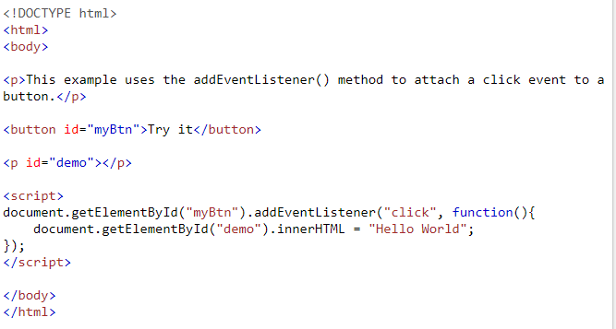

In Browser

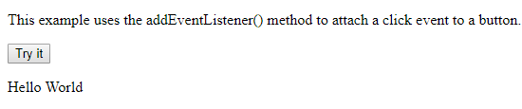

## CSS The id Selector

**-**To select an element with a specific id, write a hash (#) character, followed by the id of the element.

-**Note:** An id name cannot start with a number!

Ex:

<body>

<p id="para1">Hello World!</p>

<p>This paragraph is not affected by the style.</p>

</body>

#para1 {

text-align: center;

color: red;

}

## Css The class Selector

-To select elements with a specific class, write a period (.) character, followed by the name of the class.

Ex:

<body>

<h1 class="center">Red and center-aligned heading</h1>

<p class="center">Red and center-aligned paragraph.</p>

</body>

.center {

text-align: center;

color: red;

}

-You can also specify that only specific HTML elements should be affected by a class.

In the example below, only <p> elements with class="center" will be center-aligned:

Ex:

<body>

<h1 class="center">This heading will not be affected</h1>

<p class="center">This paragraph will be red and center-aligned.</p>

</body>

p.center {

text-align: center;

color: red;

}

-HTML elements can also refer to more than one class.

In the example below, the <p> element will be styled according to class="center" and to class="large":

Ex:

<body>

<h1 class="center">This heading will not be affected</h1>

<p class="center">This paragraph will be red and center-aligned.</p>

<p class="center large">This paragraph will be red, center-aligned, and in a large font-size.</p>

</body>

p.center {

text-align: center;

color: red;

}

p.large {

font-size: 300%;

}

-If you have elements with the same style definitions, like this:

h1, h2, p {  
    text-align: center;  
    color: red;  
}

**HTML CSS ../**

<link rel="stylesheet" href="../styles/firstday.css"

../ it means go to before folder

**Html Default Block element**

Content 100%(width), padding 0% (0% top + 0% bottom 0% left + 0% right), border 0%(0% top + 0% bottom 0% left + 0% right) are as default for every block element.

Ex:

h1{

width: 50%;

padding: 0% 25%;

border: 0px;

}

50+25+25 =100

Ex2:

Screen 1000px

Content+padding+border

h1{

width: 50%;

padding: 0% 25%;

border: 1px solid black;

}

What is h1 size from screen ?

Width: 50% = 50% from 1000 px= 500px

padding: 0% 25% = 250px left +250px right=500

border: 1px left +1px left right = 2px

so h1 size = 500+500+2= 1002px ohhhh that is problem

h1{

width: 50%;

padding: 0% 10%;

border: 1px solid black;

box-sizing: border-box;

margin: 0% auto;

}

**Css never fixed width and height**

Never define fixed width and height

**css units**

    <div>

        <a href="#">Dortmund</a>

        <a href="#">Bayern</a>

    </div>

div 60%

a 10% : 10% from div width

a 10vw : 10% frim device width

a 10px : will be always 10px, and it is not fixable so that not god

**css Block vs Inline**

text-align: center;

that will effect on inline elements and inside of Block elements, not on Block elements.

So the block elements will be not in center

**Css Media queries**

It uses the @media rule to include a block of CSS properties only if a certain condition is true.

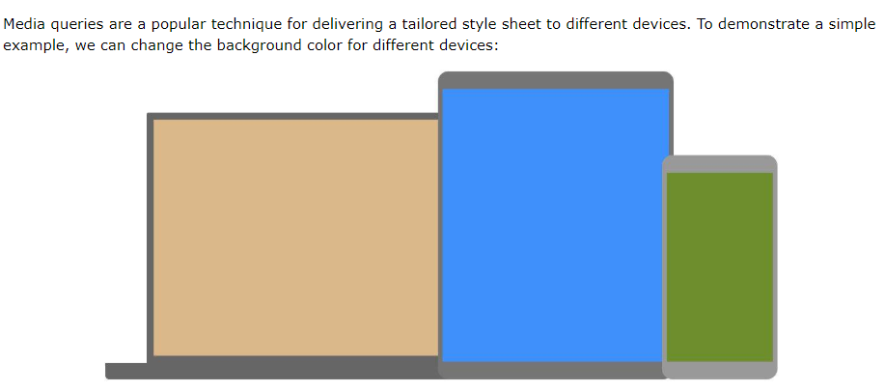

/* On screens that are 992px or less, set the background color to blue */

@media screen and (max-width: 992px) {

body {

background-color: blue;

}

}

/* On screens that are 600px or less, set the background color to olive */

@media screen and (max-width: 600px) {

body {

background-color: olive;

}

}

**Css uniq selector**

P:nth-of-chils(2) {}

That mean if p is the 2th child then do

**Css flexbox**

section{

display: flex;

flex-direction: column;

justify-content: space-between;

}

Here the section is flex-container

<section>

<div></div>

<div></div>

<div></div>

</section>

Here the divs are flex-iteams

div:nth-of-type(1) {

flex-grow: 1;

order: 2;

}

div:nth-of-type(2) {

flex-grow: 2;

order: 1;

}

div:nth-of-type(3) {

flex-grow: 0;

order: 3;

}

Div 1 will take 1-unit from rest space + order 2

Div 2 will take 2-unit from rest space + order 2

Div 3 will take 0-unit from rest space + order 3

**Css flex-basis**

div:nth-of-type(2) {

flex-basis: 100px;

}

The flex-basis property specifies the initial length of a flexible item.

Note:

section > div:nth-last-of-type(1) {

background-image: url(./images/goettingen.jpg);

}

section > div:nth-last-of-type(2) {

background-image: url(./images/lueneburg.jpg);

}

section > div:nth-last-of-type(3) {

background-image: url(./images/trier.jpg);

}

section > div {

flex-basis: 20%;

transition: flex-basis 1s linear;

}

section > div:hover {

flex-basis: 30%;

}

Transation for flex-basis not working with img…

it works with div… so the solution is to set the image as background for div =🡺 background-image: url(./images/goettingen.jpg);

**css Icon link**

<https://www.favicon-generator.org/> …. To generate 16*16 image size or icon

<head>

<link rel="icon" href="../images/img123.ico">

</head>

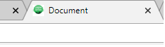

**css Flex-container x-axis vs y-axis**

**Flex-container**

section {

display: flex; it will make the section as flex-container

flex-direction: row; the iteams inside this container will go on as row

justify-content: center; items will be in the center of X-axis

align-items: center; items will be in the center of y-axis

but

flex-direction: row; .... x-axis is the row, y-axis is the Colom

flex-direction: Colom; .... x-axis is the Colom, y-axis is the row

**css Flex-shrink**

The flex-shrink property specifies how the item will shrink relative to the rest of the flexible items inside the same container. Shrink= انكماش

So with flex-shrink (no overflow ).

**Css 14_flex_project**

* {

}

That means all elements

......

to hidden elements with transition (never use display:none; nor visibility:hidden;)

opacity غموض: 0; + transition

or

height: 0; + transition

width: 0; + transition

………

**Html 14_flex_project**

a[href="#"]*5+li>img

<a href="#"></a>

<a href="#"></a>

<a href="#"></a>

<a href="#"></a>

<a href="#"></a>

<li><img src="" alt=""></li>

**………...**

button:hover ~ article {

make hover to all article elements of(button's siblings)

}

button:hover {

make hover to this button

}

button:focus + p {

when I press, do the action to only next p after button

}

button:focus ~ p {

when I press, do the action to all p elements(button's siblings)

}

button:focus {

when I press, do the action to this button

}

**HTML description list**

<h1>World cup group phase</h1>

<dl>

<dt>Grpup A teams</dt>

<dd>Brazil</dd>

<dd>Russia</dd>

<dd>Germany</dd>

<dt>Grpup B teams</dt>

<dd>France</dd>

<dd>Spain</dd>

<dd>Iran</dd>

</dl>

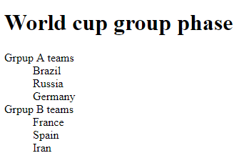

## Grid Layout

The CSS Grid Layout Module offers a grid-based layout system, with rows and columns, making it easier to design web pages without having to use floats and positioning.

.grid-container {

width: 80vw;

margin: 5vw auto;

display: grid;

grid-template: repeat(8,5vw) / repeat(6, 1fr); .. (row / columm)only width

grid-gap: 0.5vw 0.5vw;

}

.grid-items {

grid-area: 1 / 2 / span 1 / span 5;..row / columm / امتداد span row /span columm

}

**css pseudo-selectors**

it can not to copy and mark it

div p:before {

content: 'Mohammed';

color:red;

}

div p:after {

content: 'Wahba';

color:blue;

}

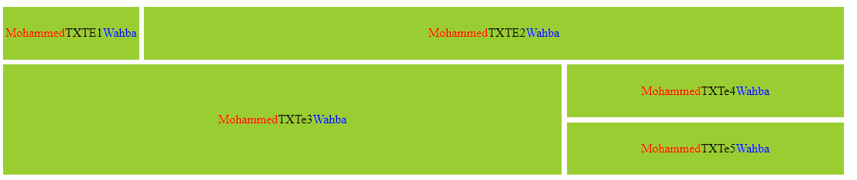

**Css conuter**

:root {

counter-reset: variabale; /* variable= 0 */

}

div p:before {

counter-increment: variabale; /* variable= variable + 1 */

content: counter(variabale) '- this Box'; /* counter(variabale) that mean print variable */

}

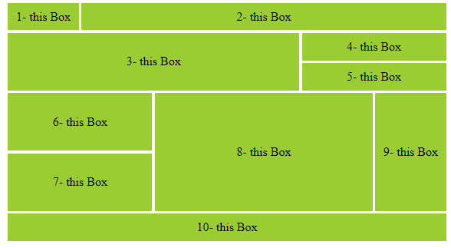

**Css unlist + conuter**

<div class="it8 grid-items">

<h2>Drinks</h2>

<ul>

<li>Coffee</li>

<li>Tea</li>

<li>Milk</li>

</ul>

</div>

:root {

counter-reset: variabale; /* variable= 0 */

}

.it8 li:before {

counter-increment: variabale; /* variable= variable + 1 */

content: counter(variabale) '. '; /* counter(variabale) that mean print variable */

}

ul {

list-style-type: none; to remove the big dot from ul

}

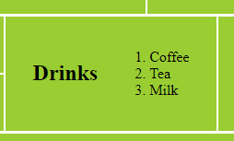

**Css public variables**

Css Variables, we define them either in :root or body.

They are case sensitive , var(--myVarible).

:root {

counter-reset: variabale; /* variable= 0 */

--varible-myBlue: #32E1FF;

--big-font: 3.5vw;

--small-font: 1.5vw;

--image-adress: https://www.gooodkdmdn,

}

.it8 {

background-color: var(--varible-myBlue)

}

**HTML CSS Grafic Grid**

.grid-container {

width: 80vw;

margin: 5vw auto;

border: 2px solid black;

display: grid;

grid-template: repeat(9, 7vw) / repeat(7, 1fr);

grid-template-areas: 'b b b b b b b'

'b b b b b b b'

'o o o o o g g'

'o o o o o g g'

'c c s t u g g'

'y y s t u g g'

'y y r r r r r'

'k k k k k k k'

'k k k k k k k';

grid-column-gap: 0.5vw;

grid-row-gap: 0.5vw;

}

.it1 {

background: blue;

grid-area: b;

}

.it2 {

background:orange;

grid-area: o;

}

.it3 {

background: green;

grid-area: g;

}

.it4 {

background: silver;

grid-area: s;

}

.it5 {

background:tan;

grid-area: t;

}

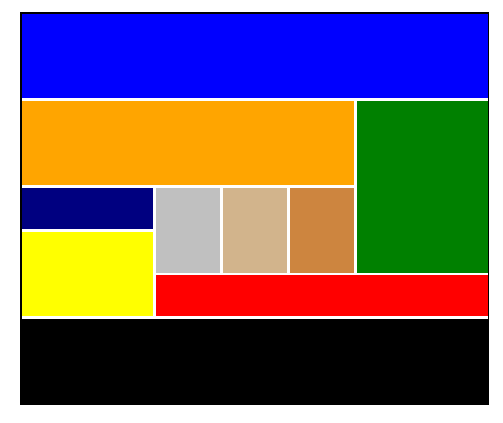

grid-template-areas: 'b b b b b b b'

'b b b b b b b'

'o o o o o g g'

'o o o o o g g'

'c c . t u g g'

'y y . t u g g'

'y y r r r r r'

'k k k k k k k'

'k k k k k k k';

. means empty spaces

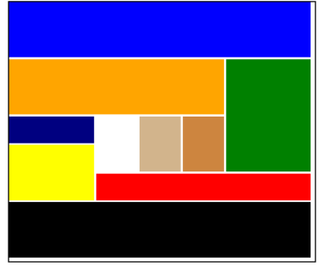

**css Nav DropDwon**

HTML

<nav id="nav">

<li>About me

<ul>

<a>Go</a>

<a>Ea</a>

<a>ME</a>

</ul>

</li>

<li>Cooking stuff</li>

<li>traveling stuff</li>

<li>Coding stuff</li>

<li>Info</li>

</nav>

css

nav > li > ul {

display: none;

}

nav > li:hover > ul { go to ul and do {} when I hover the li

display: flex;

flex-direction: column;

}

# CSS text-shadow

text-shadow: h-shadow v-shadow blur-radius color;

text-shadow: 0vw 0 5vw red;



text-shadow: -1vw 0 2vw red,1vw 0 2vw yellow, 0 -1vw 2vw red, 0 1vw 2vw yellow;



**css gradient**

background: linear-gradient(90deg, blue, white);

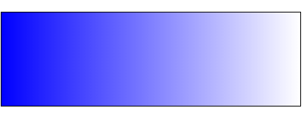

background: radial-gradient( blue 25%, white 75%);

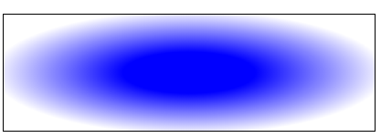

# css transform Property

The transform property applies a 2D or 3D transformation to an element. This property allows you to rotate, scale, move, skew انحرف, etc., elements.

transform: none|transform-functions();

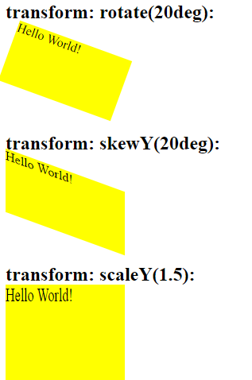

<https://www.w3schools.com/cssref/css3_pr_transform.asp>

and we can do : transition: transform 0.4s ease-out;

**CSS Animations**

CSS animations allows animation of most HTML elements without using JavaScript or Flash!

@keyframes VaribaleName {

from {background: white;}

to {background:black; width: 30vw;}

}

section div {

border: 1px solid black;

height: 10vw; width: 10vw;

background: red;

position: relative;

top: 40%;

animation-name: VaribaleName;

animation-duration: 5s;

animation-timing-function: linear;

}

@keyframes VaribaleName {

0% {transform: translate(0vw,0) ; }

25% {transform: translate(5vw,10vw) rotate(25deg); }

50% {transform: translate(10vw,-10vw); }

75% {transform: translate(30vw, 0) rotate(75deg); }

100% {transform: translate(40vw, 5vw) rotate(-5deg); }

}

section:hover div {

border: 1px solid black;

height: 10vw; width: 10vw;

background: red;

position: relative;

top: 40%;

animation-name: VaribaleName;

animation-duration: 5s;

animation-timing-function: linear;

animation-delay: 0.5s;

animation-iteration-count: infinite;

animation-direction: alternate;

/*or animation: VaribaleName 5s linear 0.5s infinite alternate; *

}

https://www.w3schools.com/css/css3_animations.asp

@keyframes VaribaleName {

0% {transform: translate(0vw,10vw) rotate(20deg) ; }

25% {transform: translate(45vw,0vw); }

50% {transform: translate(90vw,10vw) rotate(-20deg); }

75% {transform: translate(45vw, 20vw); }

100% {transform: translate(0vw, 10vw);}

}

section div {

border: 1px solid black;

height: 10vw; width: 10vw;

border-radius: 50px;

background: red;

text-align: center;

position: relative;

top: 10%;

animation-name: VaribaleName;

animation-duration: 10s;

animation-timing-function: linear;

animation-delay: 0.5s;

animation-iteration-count: infinite;

/* animation-direction: alternate; */

/*or animation: VaribaleName 5s linear 0.5s infinite alternate; */

}

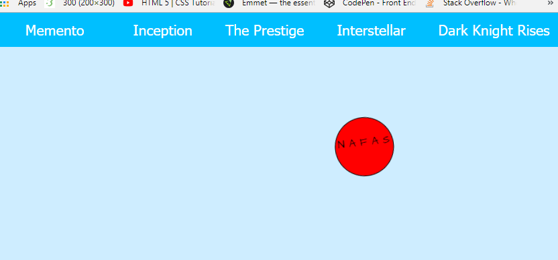

# HTML Basic Icons , Font Awesome

To use the Font Awesome icons, add the following line inside the <head> section of your HTML page:

<link rel="stylesheet" href="https://cdnjs.cloudflare.com/ajax/libs/font-awesome/4.7.0/css/font-awesome.min.css">

# You place Font Awesome icons by using the prefix fa and the icon's name.

## 

**HTML CSS root doesn’t include the**

Important Note: the root doesn’t include the Body.

So do that:

:root {

background: #cccccc;

margin: 0;

border: 1px solid black;

padding: 0;

}

body {

margin: 0;

padding: 0;

}

# CSS Flexbox here all explain

Before the Flexbox Layout module, there were four layout modes:

* Block, for sections in a webpage
* Inline, for text
* Table, for two-dimensional table data
* Positioned, for explicit position of an element

The Flexible Box Layout Module, makes it easier to design flexible responsive layout structure without using float or positioning.

To start using the Flexbox model:

1. you need to first define a flex container (Parent Element).

HTML:

<div class="flex-container">

<div>1</div>

<div>2</div>

<div>3</div>

</div>

CSS:

The flex container becomes flexible by setting the display property to

.flex-container {

display: flex;

}

2-flex items

The **direct** child elements of a flex container automatically becomes flexible (flex) items.

HTML:

<div class="flex-container"> flex container

<div>1</div> flex item

<div>2</div> flex item

<div>3</div> flex item

</div>

So the whole code is :

<body>

<div class="flex-container">

<div>1</div>

<div>2</div>

<div>3</div>

</div>

</body>

.flex-container {

display: flex;

background-color: DodgerBlue;

}

.flex-container > div {

background-color: #f1f1f1;

margin: 10px;

padding: 20px;

font-size: 30px;

}

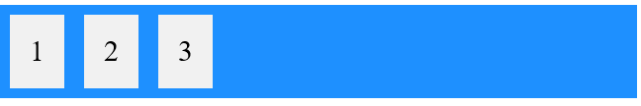

# ……………………………………………………………………..

The flex container properties are:

* [flex-direction](https://www.w3schools.com/css/css3_flexbox.asp#flex-direction)
* [flex-wrap](https://www.w3schools.com/css/css3_flexbox.asp#flex-wrap) لف
* [flex-flow](https://www.w3schools.com/css/css3_flexbox.asp#flex-flow)
* [justify-content](https://www.w3schools.com/css/css3_flexbox.asp#justify-content)
* [align اصطف محاذاة -items](https://www.w3schools.com/css/css3_flexbox.asp#align-items)
* [align-content](https://www.w3schools.com/css/css3_flexbox.asp#align-content)

## The flex-direction Property

The flex-direction property defines in which direction the container wants to stack the flex items.

.flex-container { …… flex-direction: column;

display: flex;

flex-direction: column;

background-color: DodgerBlue;

}

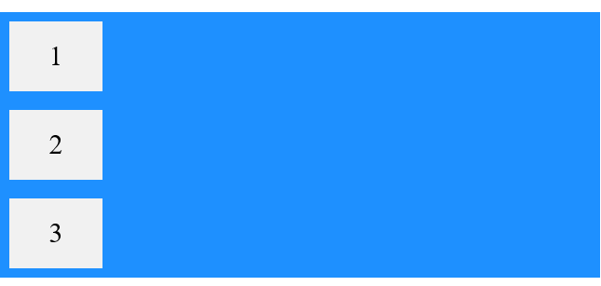

.flex-container { ….. flex-direction: column-reverse;

display: flex;

flex-direction: column-reverse;

background-color: DodgerBlue;

}

# 

.flex-container { ….. flex-direction: row; is as Default

display: flex;

flex-direction: row;

background-color: DodgerBlue;

}

# 

.flex-container { …… flex-direction: row-reverse;

display: flex;

flex-direction: row-reverse;

background-color: DodgerBlue;

}

# 

## The flex-wrap Property

The flex-wrap لف property specifies whether the flex items should wrap or not.

.flex-container { …. flex-wrap: wrap;

display: flex;

flex-wrap: wrap;

background-color: DodgerBlue;

}

# 

.flex-container { ….. flex-wrap: nowrap;

display: flex;

flex-wrap: nowrap;

background-color: DodgerBlue;

}

# 

.flex-container { ….. flex-wrap: wrap-reverse;

display: flex;

flex-wrap: wrap-reverse;

background-color: DodgerBlue;

}

# 

## The flex-flow Property

The flex-flow property is a shorthand property for setting both the flex-direction and flex-wrap properties.

.flex-container { … flex-flow: row wrap;

display: flex;

flex-flow: row wrap;

background-color: DodgerBlue;

}

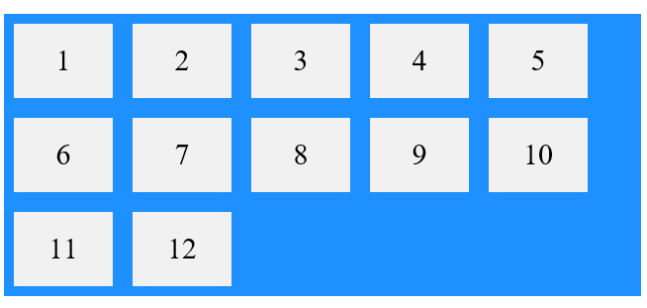

.flex-container { .. flex-flow: column wrap;

display: flex;

flex-flow: column wrap;

background-color: DodgerBlue;

height: 400px; ….. Important, try it without it

}

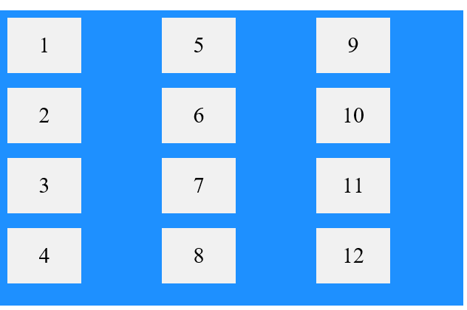

## The justify-content Property

The justify-content property is used to align the flex items on X-axis.

The center value aligns the flex items at the center of the container:

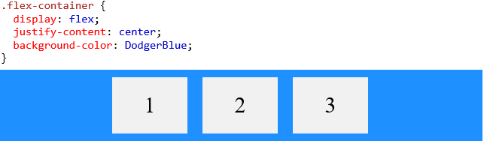

The flex-start value aligns the flex items at the beginning of the container (this is default):

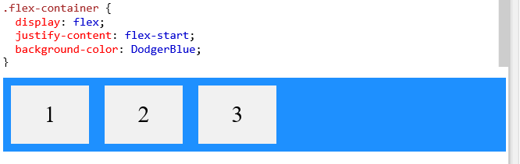

The flex-end value aligns the flex items at the end of the container:

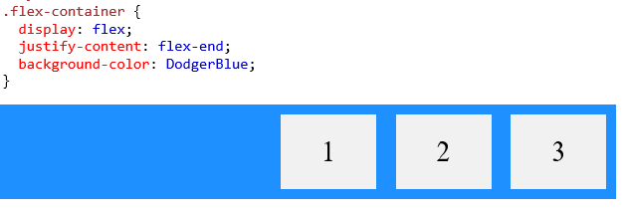

The space-around value displays the flex items with space before, between, and after the lines:

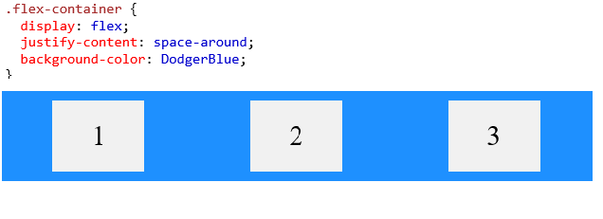 The space-between value displays the flex items with space between the lines:

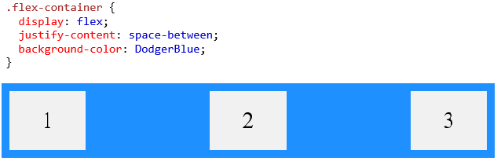

## The align-items Property

The align-items property is used to align the flex items vertically on Y-axis. عموديا

The stretch value stretches the flex items to fill the container (this is default):

stretch تمتد

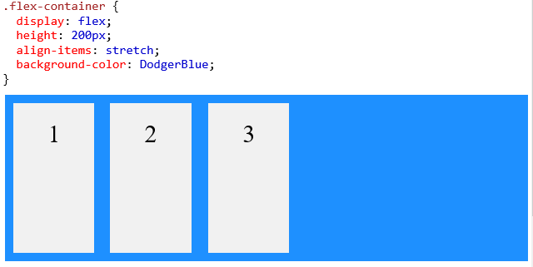

The center value aligns the flex items in the middle of the container:

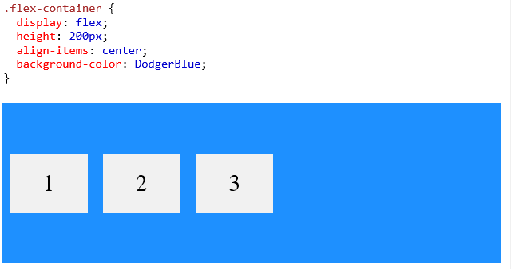

The flex-start value aligns the flex items at the top of the container:

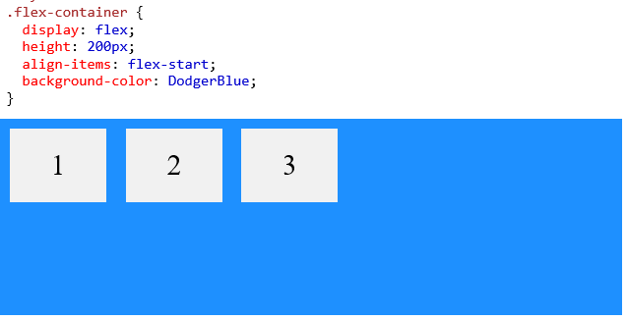

The flex-end value aligns the flex items at the bottom of the container:

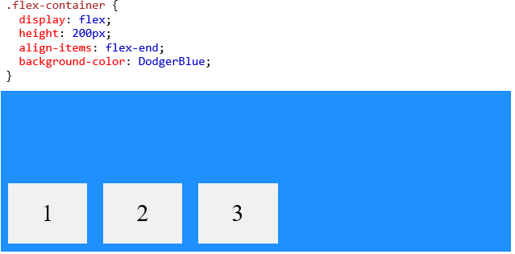

The baseline value aligns the flex items such as their baselines aligns:

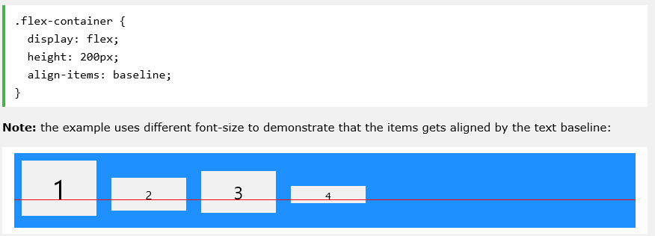

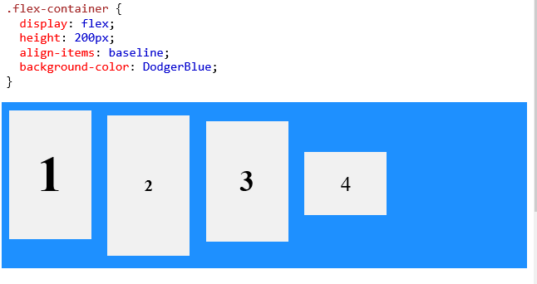

## The align-content Property

The align-content property is used to align the flex lines ( not the items, but the line of items).

In these examples we use a 600 pixels high container, with the flex-wrap property set to *wrap*, to better demonstrate the align-content property.

The stretch value stretches the flex lines to take up the remaining space (this is default):

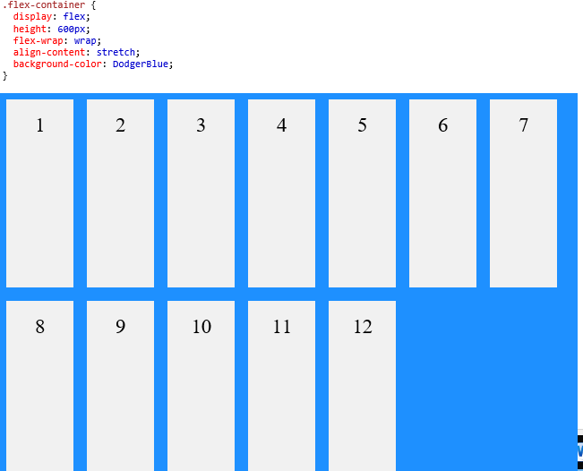

The space-between value displays the flex lines with equal space between them:

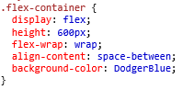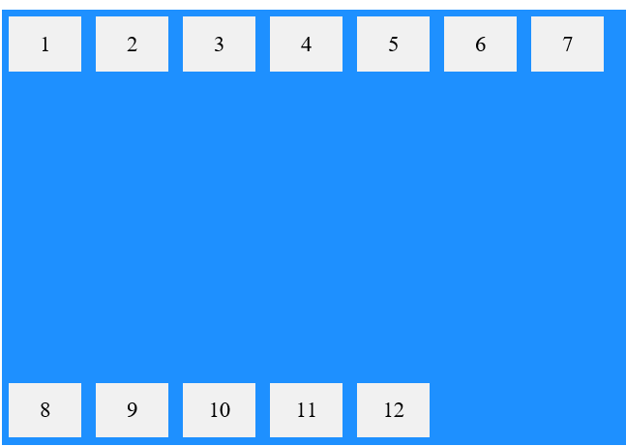

The space-around value displays the flex lines with space before, between, and after them:

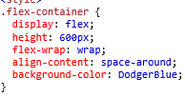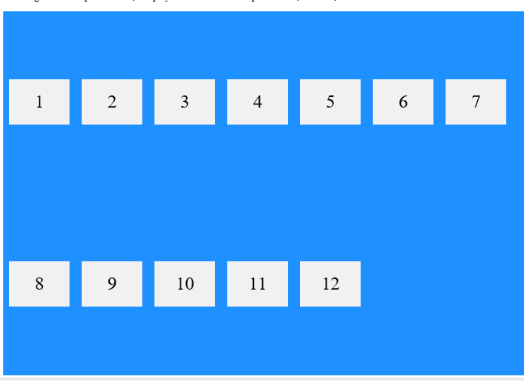

The center value displays display the flex lines in the middle of the container:

.flex-container {  
  display: flex;  
  height: 600px;  
  flex-wrap: wrap;  
  align-content: center;  
}

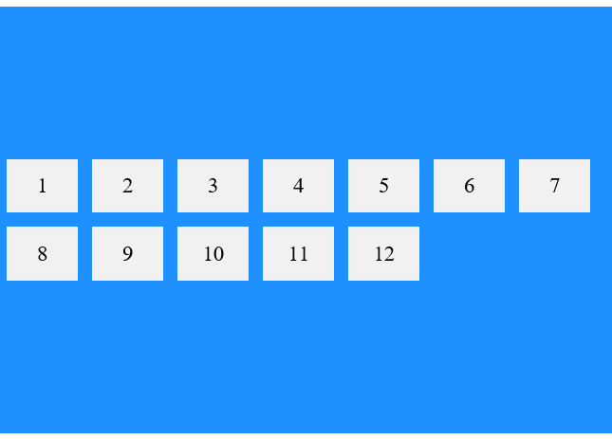

The flex-start value displays the flex lines at the start of the container:

.flex-container {  
  display: flex;  
  height: 600px;  
  flex-wrap: wrap;  
  align-content: flex-start;  
}

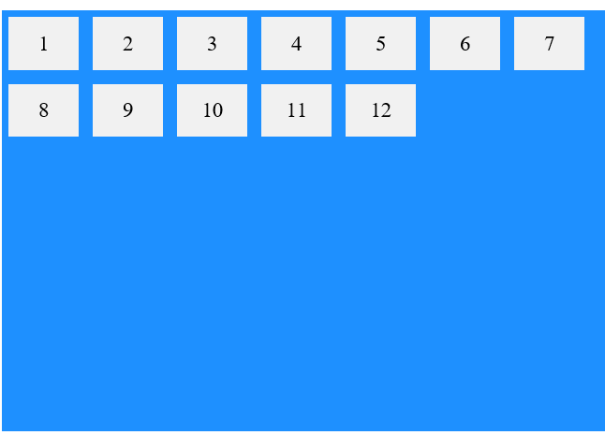

The flex-end value displays the flex lines at the end of the container:

.flex-container {  
  display: flex;  
  height: 600px;  
  flex-wrap: wrap;  
  align-content: flex-end;  
}

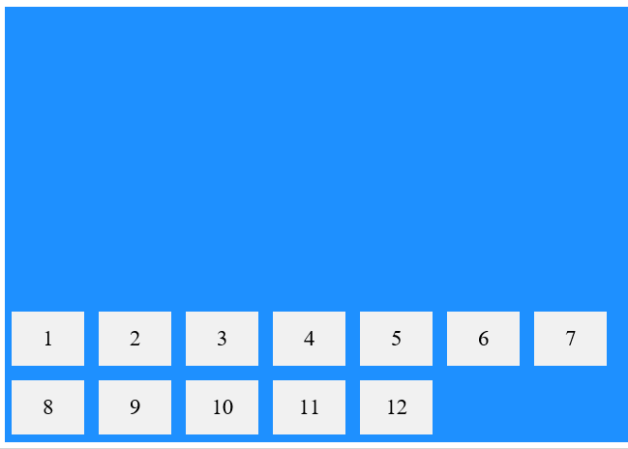

## Perfect Centering

In the following example we will solve a very common style problem: perfect centering.

.flex-container {

display: flex;

height: 300px;

justify-content:center; ….x-axis

align-items: center; ….y-axis

}



# ……………………………………………………………………..

The flex items properties are:

* [order](https://www.w3schools.com/css/css3_flexbox.asp#order)
* [flex-grow](https://www.w3schools.com/css/css3_flexbox.asp#flex-grow)
* [flex-shrink](https://www.w3schools.com/css/css3_flexbox.asp#flex-shrink)
* [flex-basis](https://www.w3schools.com/css/css3_flexbox.asp#flex-basis)
* [flex](https://www.w3schools.com/css/css3_flexbox.asp#flex)
* [align-self](https://www.w3schools.com/css/css3_flexbox.asp#align-self)

The order property specifies the order of the flex items.

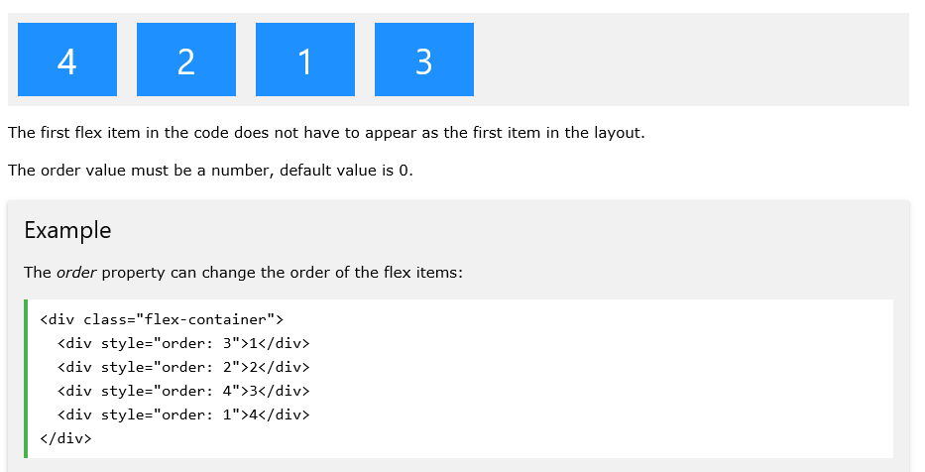

The flex-grow property specifies how much a flex item will grow relative to the rest of the flex items. grow تنمو

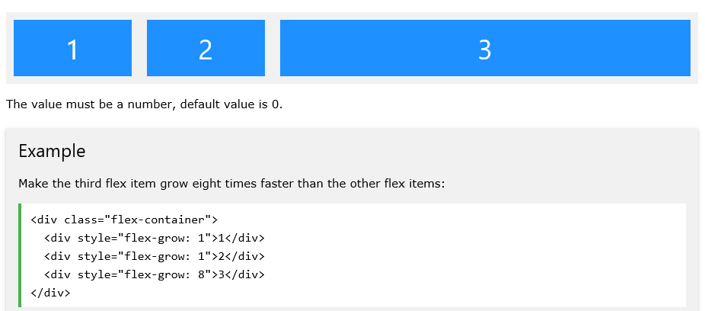

Or

<div class="flex-container">

<div >1</div>

<div >2</div>

<div style="flex-grow: 1">3</div> … here this div will take all the rest

</div>

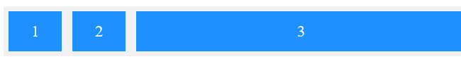

#main div {

flex-grow: 1; .... = grow 1 , all items will share the rest space

}

## The flex-shrink Property

The flex-shrink property specifies how much a flex item will shrink relative to the rest of the flex items. shrink تقلص

خاصية الانكماش تحدد مقدار تقلص عنصر المرن بالنسبة لبقية العناصر المرنة.

The value must be a number, default value is 1.

0 no shrink , it will be its normal size

1 shrink, it will shrink of 1 unite and it will be smaller size

2 shrink, it will shrink of 2 unite and it will be more smaller size

<div class="flex-container">

<div>1</div>

<div>2</div>

<div style="flex-shrink: 0">3</div>

<div style="flex-shrink: 1">4</div>

<div style="flex-shrink: 2">5</div>

<div style="flex-shrink: 3">6</div>

<div>7</div>

<div>8</div>

<div>9</div>

<div>10</div>

</div>

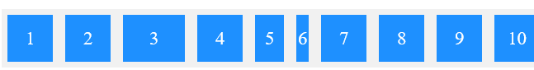

## The flex-basis Property

The flex-basis property specifies the initial length of a flex item.

HTML:

<p>Set the initial length of the third flex item to 200 pixels:</p>

<div class="flex-container">

<div>1</div>

<div>2</div>

<div style="flex-basis:200px">3</div>

<div>4</div>

</div>

Css:

.flex-container > div {

background-color: DodgerBlue;

color: white;

width: 100px;

margin: 10px;

text-align: center;

line-height: 75px;

font-size: 30px;

}

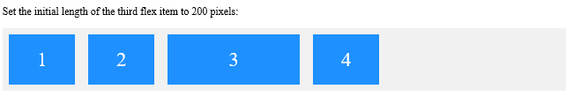

## The flex Property

The flex property is a shorthand property for the flex-grow, flex-shrink, and flex-basis properties

<div class="flex-container">

<div>1</div>

<div>2</div>

<div style="flex: 0 0 200px">3</div> … grow=0 no grow,shrink=0 no shrink it will be its normal size , basis=200ox

<div>4</div>

</div>

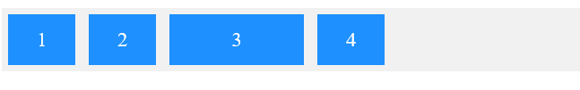

## The align-self Property

The align-self property specifies the alignment المحاذاة لfor the selected item inside the flexible container.

The align-self property overrides لغى the default alignment set by the container's align-items property.

align-self: auto|stretch|center|flex-start|flex-end|baseline|initial|inherit;

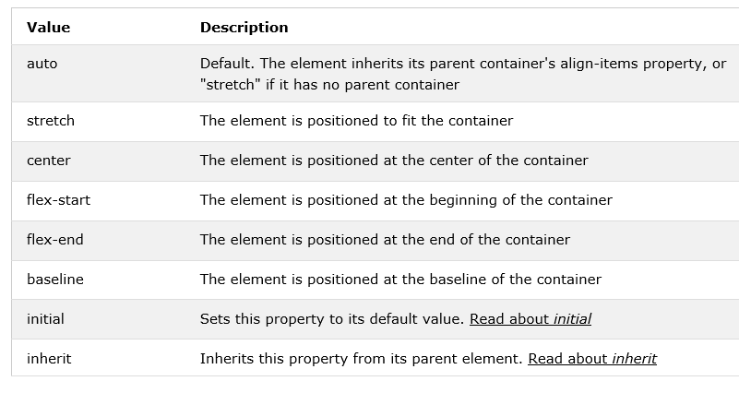

Ex.

<div id="main">

<div style="background-color:coral;">RED</div>

<div style="background-color:lightblue;" id="myBlueDiv">BLUE</div>

<div style="background-color:lightgreen;">Green div with more content.</div>

</div>

#main {

width: 220px;

height: 300px;

border: 1px solid black;

display: flex;

align-items: flex-start;

}

#main div {

flex: 1; .... = grow 1 , all items will share the rest space

}

#myBlueDiv {

align-self: center;

}

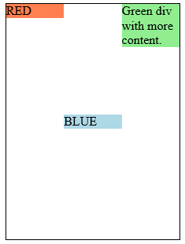

……………………………………………………………………………………

The Summary Flex-container + Flex-items

**Flex-container**

display: flex;

flex-direction: row;

justify-content: space-between;

align-items: flex-start;

flex-wrap: wrap;

**Flex-items**

flex-basis: 20%;

flex-grow: 0.5;

flex-shrink: 1;

align-self: center;

order: 2;

shortcut:

in **Flex-container**

flex-direction: row;

flex-wrap: wrap

shortcut >>>> flex-flow: row warp;

in **Flex-items**

flex-basis: 20%;

flex-grow: 0.5;

flex-shrink: 1;

shortcut >>>> flex: 0.5 1 20%;

**HTML Input Placeholder**

HTML

<input type="text" id="id8" placeholder="Here your name">

Css

#id8::placeholder {

color: lightblue;

}



**Css :root { vs body,nav,li, a, img, p {**

:root {

margin: 0;

padding: 0;

box-sizing: border-box;

}

:root will not effect on the items that have default values.

Ex. P has default value, so :root will not effect on P.

So the solution :

body, nav, li, a, img, p {

margin: 0;

padding: 0;

box-sizing: border-box;

}

**\*CSS Image Sprites**

An image sprite is a collection of images put into a single image.

A web page with many images can take a long time to load and generates multiple server requests.

Using image sprites will reduce the number of server requests and save bandwidth.

**SASS SCSS**

Sass (Syntactically Awesome Style Sheets) is an extension of CSS that enables you to use things like variables, nested rules, inline imports and more. It also helps to keep things organised and allows you to create style sheets faster.

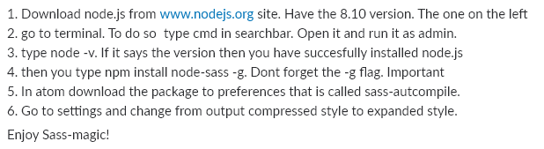

[**https://sass-lang.com/guide**](https://sass-lang.com/guide)

[**https://www.sassmeister.com**](https://www.sassmeister.com)

**https://sass-lang.com/documentation/file.SASS_REFERENCE.html**

1-Nested Syntax بناء جملة متداخلة

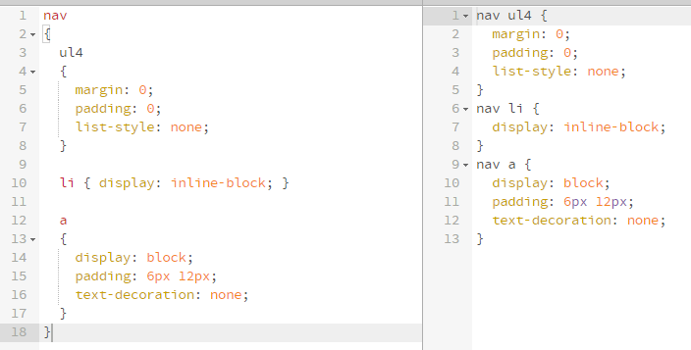

2-name spaces , … I never like it

article {

text:

{

align: center;

direction: none;

}

}

3-partials جزئيات

_nav.scss _form.scss _footer.scss

// main.scss

@import 'nav';

@import 'form';

@import 'footer';

## 4-Variables

Important note :

-Use the variable in properties as **$var**

Ex :

$text_size: 3vw;

li:nth-of-type(1){ font-size: $text_size;}

-Use the variable in Selectors as **#{$var}**

Ex :

$ele: electornics; // ele is varible for the the class 'electornics'

section.#{$ele} { color: red; }

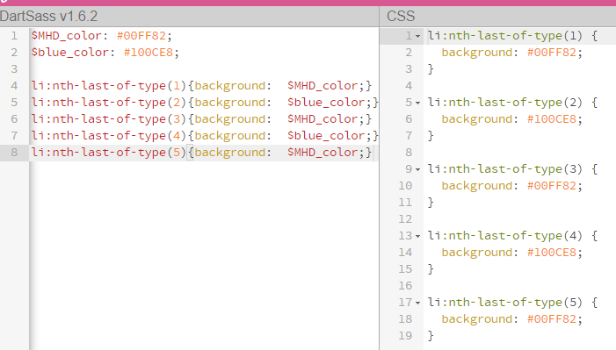

## 5-Operators

Doing math in your CSS is very helpful. Sass has a handful of standard math operators like +, -, *, /, and %

$MHD_color: #00FF82;

$blue_color: #100CE8;

$text_size: 3vw;

li:nth-of-type(1){background: $MHD_color; font-size: $text_size;}

li:nth-of-type(2){background: $blue_color; font-size: $text_size*2;}

li:nth-of-type(3){background: $MHD_color; font-size: $text_size*3;}

li:nth-of-type(4){background: $blue_color; font-size: $text_size*4;}

li:nth-of-type(5){background: $MHD_color; font-size: $text_size*5;}

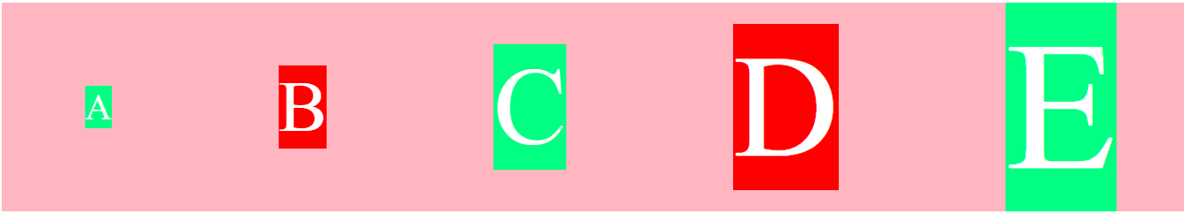

Or to calculate the width and height

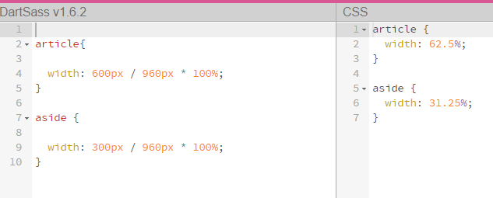

## 6- Variable for Class .#{$var} or Variable for ID ##{$var}

HTML

<section class="electornics"></section>

scss

$ele: electornics; // ele is varible for the the class 'electornics'

section.#{$ele} { color: red; }

## will convert to css

section.electornics {

color: red;

}

7-for Loop , like ruby @for $i from 1 to 10 { }

scss

nav {

@for $i from 1 to 11 {

li:nth-of-type(#{$i}) { font-size: 1vw * $i; background: rgba(48, 49, 255, $i/10);}

}

## will convert to css

nav li:nth-of-type(1) {

font-size: 1vw;

background: rgba(48, 49, 255, 0.1);

}

nav li:nth-of-type(2) {

font-size: 2vw;

background: rgba(48, 49, 255, 0.2);

}

nav li:nth-of-type(3) {

font-size: 3vw;

background: rgba(48, 49, 255, 0.3);

}

nav li:nth-of-type(4) {

font-size: 4vw;

background: rgba(48, 49, 255, 0.4);

}

nav li:nth-of-type(5) {

font-size: 5vw;

background: rgba(48, 49, 255, 0.5);

}

8-if , like ruby @if $i == 1 { } @else if $i > 1 { } @else if $i > 1 { } @else { }

@if $pos == 1 { span:before {content: 'only '+'#{$quantity} ';} }

@else if $pos == 2 { span:before {content: 'only '+'#{$quantity} ';} }

@else if $pos == 3 { span:before {content: 'only '+'#{$quantity} ';} }

@else { span:before {content: 'only '+'#{$quantity} ';} }

nav

{

@for $i from 1 to 6

{

li:nth-of-type(#{$i})

{

font-size: 1vw * $i;

background: rgba(48, 49, 255, $i/10);

width: $i*10 + px;

&:after

{

@if $i == 1 { content:'#{$i}'+ st; }@else if $i > 1 { content:'#{$i}'+ th; }

}

}

}

}

Css

nav li:nth-of-type(1) {

font-size: 1vw;

background: rgba(48, 49, 255, 0.1);

width: 10px;

}

nav li:nth-of-type(1):after {

content: "1st";

}

nav li:nth-of-type(2) {

font-size: 2vw;

background: rgba(48, 49, 255, 0.2);

width: 20px;

}

nav li:nth-of-type(2):after {

content: "2th";

} ……. an so on

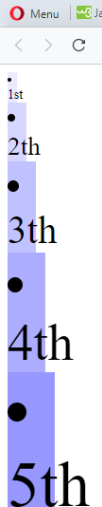

7- **each** Loop

The @each directive usually has the form @each $var in <list or map>. $var can be any variable name, like $length or $name, and <list or map> is a SassScript expression that returns a list or a map.

The @each rule sets $var to each item in the list or map, then outputs the styles it contains using that value of $var.

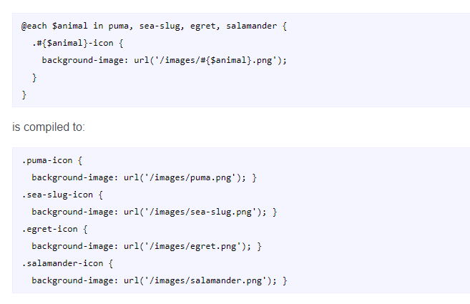

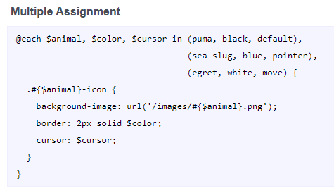

@each $pos, $team in (1, bayern), (2, dortmund), (3, frankfurt), (4, gladbach), (5, koln), (6, mainz), (7, nurnberg), (8, pauli)

{

&:nth-of-type(#{$pos})

{

background-image: url(../images/#{$team}.png);

}

}

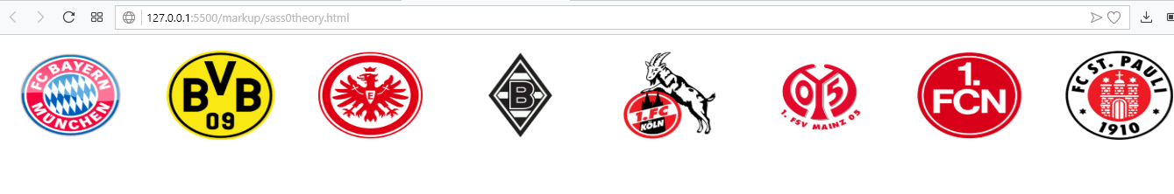

Ex in loop: 14 lines in scss will generate 50 lines in css

Scss

nav

{

@for $i from 1 to 6

{

li:nth-of-type(#{$i})

{

font-size: 1vw * $i;

background: rgba(48, 49, 255, $i/10);

width: $i*10 + px;

&:after { content:'#{$i}'; }

}

}

}

 It will generate the CSS

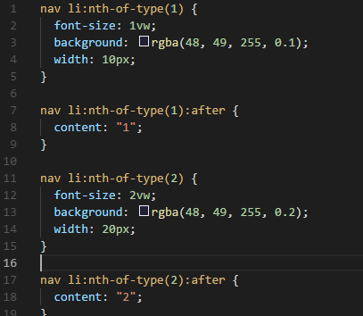

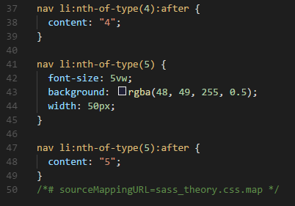

**Css sectors > + ~**

space all children and grandchildren. div li

>all children, no grandchildren. div > li

~ all next siblings, not before siblings. div **~** li

+ only the next direct sibling. div **+** li

**css position: sticky;** **لزج**

the user will still see the nav while he scrolls down the page

nav {

margin: 1.1vw 0;

background: deepskyblue;

height: 5.4vw;

position: sticky;

top: 0;

}

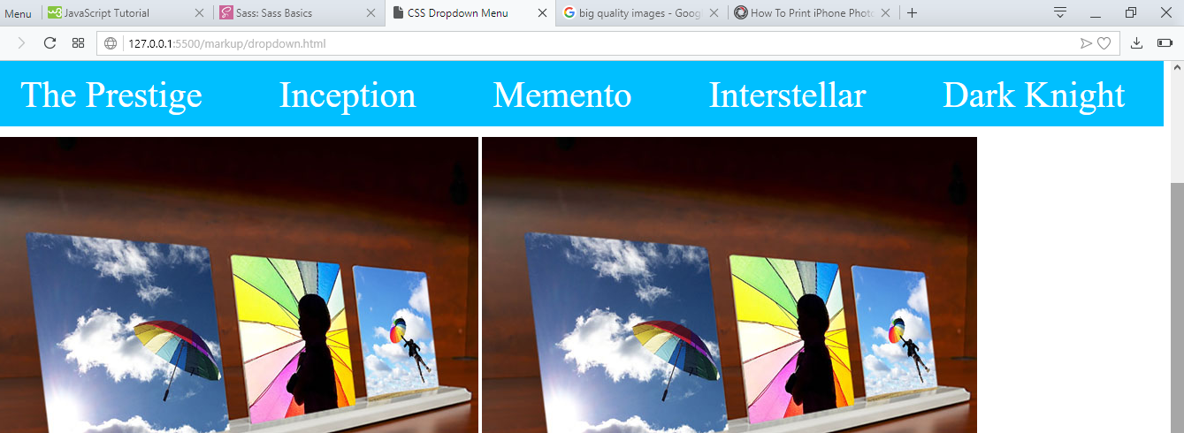

**css background-blend-mode مزج Property**

this property defines the blending مزج mode of each background layer (color and/or image).

Css Example

footer {

height: 30vw;

background: url(../../images/planesky.jpg) orange;

background-repeat: no-repeat;

background-size: 100% 100%;

background-blend-mode: darken;

}

**Scss Media queries, nth-last-of-type**

nav

{

display: flex;

flex-direction: row;

@media screen and (max-width: 768px) { flex-direction: column; }

Li

{

list-style-type: none;

@media screen and (max-width: 768px) { font-size: 5vw; }

&:nth-last-of-type(even) { background: red; }

}

}

**Scss Shop Exercise**

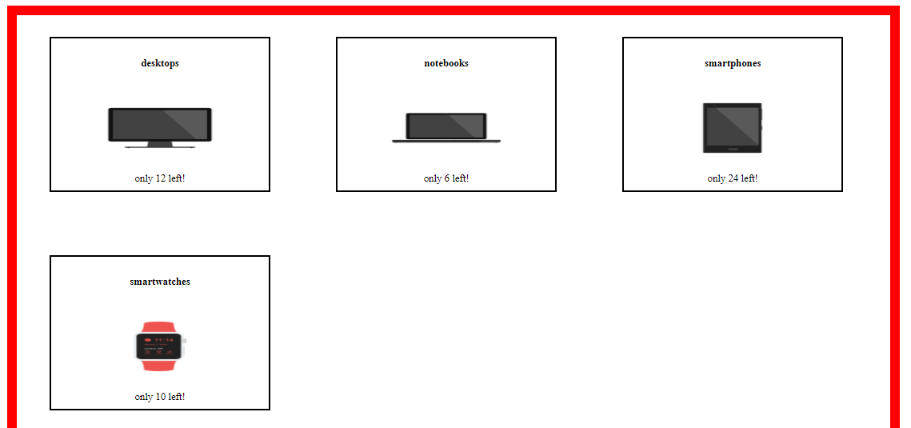

body

{

main

{

border: 15px red solid;

display: flex;

justify-content: flex-start;

flex-wrap: wrap;

margin: 10vw auto;

width: 80vw;

height: 40vw;

section {

margin: 2vw 3vw;

border: 2px black solid;

display: flex;

flex-direction: column;

justify-content: space-around;

align-items: center;

width: 25%;

height: 35%;

div {

padding: 3vw 6vw;

background-size: 100% 100% ;

background-repeat: no-repeat;

background-position: center center;

}

@each $pos, $team, $quantity in (1, desktops, 12), (2, notebooks, 6), (3, smartphones, 24), (4, smartwatches, 10)

{

&:nth-of-type(#{$pos})

{

div

{

background-image: url(../images/#{$team}.png);

}

h4:before

{

content: '#{$team}';

}

@if $pos == 1 { span:before {content: 'only '+'#{$quantity} ';} }

@else if $pos == 2 { span:before {content: 'only '+'#{$quantity} ';} }

@else if $pos == 3 { span:before {content: 'only '+'#{$quantity} ';} }

@else { span:before {content: 'only '+'#{$quantity} ';} }

}

}

}

}

}

**SASS Placeholder –to call group of public variables (not in css)**

**The same properties and the same values**

To create it :

%Name_group_variables { }

To call him :

@extend %Name_group_variables;

%Name_group_variable {

display: flex;

flex-direction: column;

}

form, div {

@extend %Name_group_variable;

}

sass Example

%set_padding {

padding:0 vw;

}

%btn_button {

font-family: thoma;

font-size: 1.5vw;

padding: 1vw 2vw;

}

%make_flex {

display: flex;

flex-direction: column;

justify-content: space-around;

align-items: center,

}

p, h1 {

@extend %set_padding;

}

div {

@extend %make_flex;

}

button {

@extend %btn_button;

}

**SASS mixin –to call group of public variables (not in css)**

**The same properties but the different values**

To create it :

@Name_group_variables($var1, $var2, $var3, $var4, $var5: default_value_var5) { }

To call him :

@include ame_group_variables(vlaue, vlaue, vlaue, vlaue, value or nothing to get default);

@mixin make_flex($display, $direction, $justify, $align, $width, $height: auto) {

display: $display;

direction: $direction;

justify-items: $justify;

align-items: $align;

width: $width;

height: $height;

}

div {

@include make_flex(flex, column, space-around, center, 75vw);

}

form {

@include make_flex(flex, row, center, center, 90vw);

}

### Sass Script Functions

<https://sass-lang.com/documentation/file.SASS_REFERENCE.html#functions>

…………………………………………………………………………………………………………..

**bootstrapstudio**

A powerful desktop app for creating responsive websites using the Bootstrap framework.

Bootstrap is the most popular HTML, CSS, and JavaScript framework for developing responsive, mobile-first websites.

Bootstrap is completely free to download and use!

1. Include CDN (online )

copy the css js links to html

<https://getbootstrap.com/docs/4.0/getting-started/introduction/>

when we set js link in the top of html, is special event that is called (on Dom content load)

2-Download vs Include CDN

Download:1- work offline,2- to see bootstrap content, 3-Modify

Include CDN: 1- Minified versions, parse تحليل faster, load faster, better production تحضير

**bootstrapstudio**

Bootstrap's grid system is built with flexbox and allows up to 12 columns across the page.

Then the Rows define as stack.

Important note : when I write class="row" , then mains that row is “Bootstrap's grid system is built with flexbox and allows up to 12 columns across the page.”

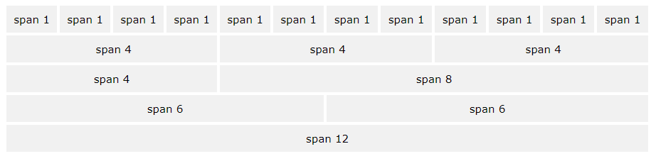

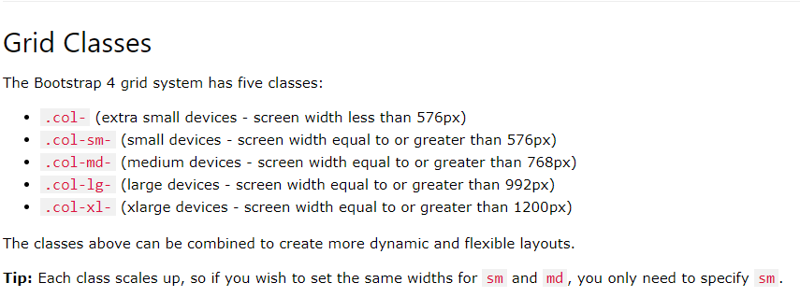

create a row (<div class="row">). Then, add the desired number of columns (tags with appropriate.col-*-* classes). The first star (*) represents the responsiveness: sm, md, lg or xl, while the second star represents a number, which should add up to 12 for each row.

 instead of adding a number to each col, let bootstrap handle the layout, to create equal width columns: two "col" elements = 50% width to each col. three cols = 33.33% width to each col. four cols = 25% width, etc. You can also use .col-sm|md|lg|xl to make the columns responsive.

Explain from teacher:

<div class="row"> …class row means to set a new row

<div class="example col-4">some content</div>

<div class="col-1"></div>

<div class="example col-4">some content</div>

<div class="example col-2">some content</div> class col-2 means to span a 2 cols

</div>

.example {

background: red;

color: blue;

font-size: 2vw;

}



<div class="row">

<div class="example col">some content</div>

<div class="col"></div>

<div class="example col">some content</div>

<div class="example col">some content</div>

</div>

<div class="row">

<div class="example col">some content</div>

<div class="col"></div>

<div class="example col">some content</div>

<div class="example col">some content</div>

</div>

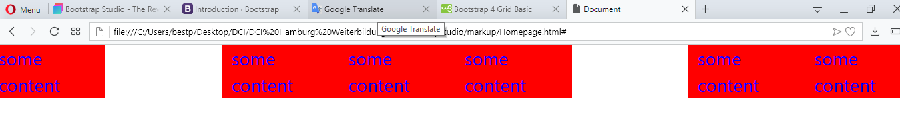

**Text Colors**

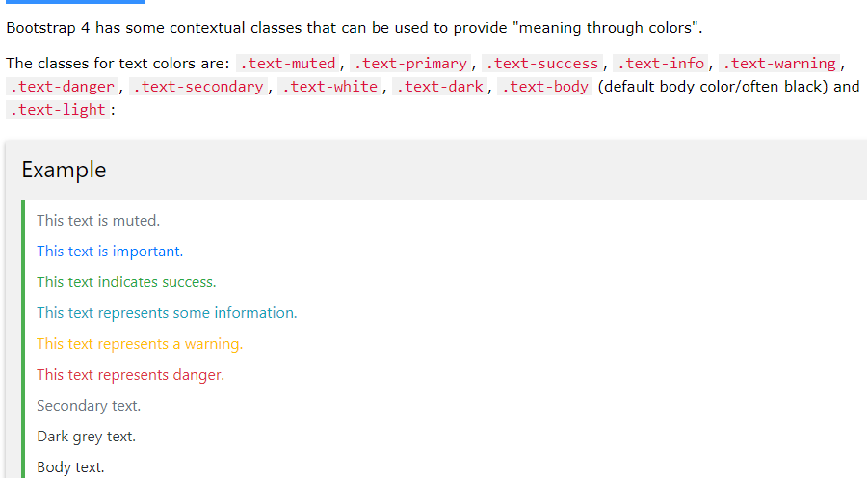

<div class="container">

<h2>Contextual Colors</h2>

<p>Use the contextual classes to provide "meaning through colors":</p>

<p class="text-muted">This text is muted.</p>

<p class="text-primary">This text is important.</p>

<p class="text-success">This text indicates success.</p>

<p class="text-info">This text represents some information.</p>

<p class="text-warning">This text represents a warning.</p>

<p class="text-danger">This text represents danger.</p>

<p class="text-secondary">Secondary text.</p>

<p class="text-dark">This text is dark grey.</p>

<p class="text-body">Default body color (often black).</p>

<p class="text-light">This text is light grey (on white background).</p>

<p class="text-white">This text is white (on white background).</p>

</div>

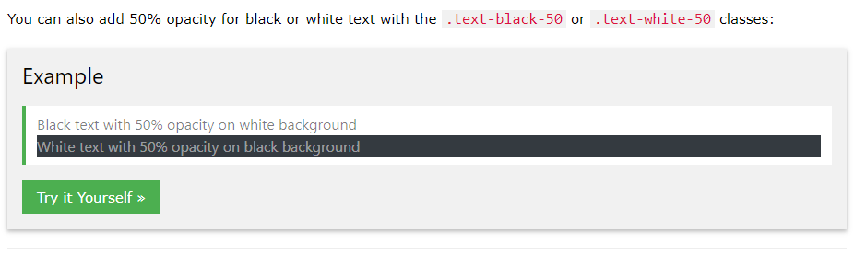

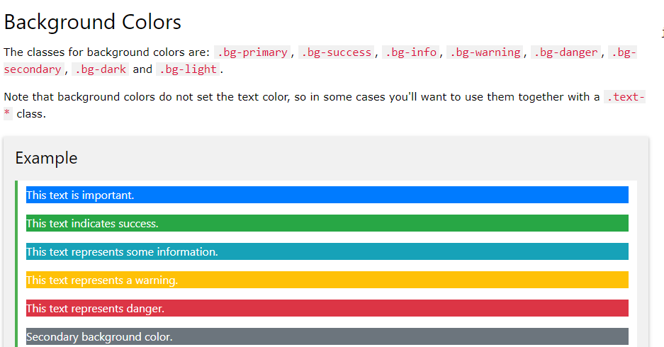

**Class container vs container-fluid**

Container class: the element will take the width of 80% and will set in center.

Container-fluid class: the element will take the width of 100%.

<body>

    <div class="row" >

        <div class="col-12 col-md-6 col-lg bg-primary">DIV 1 A row</div>

        <div class="col-12 col-md-6 col-lg bg-success">DIV 1 B row</div>

        <div class="col-12 col-md-6 col-lg bg-danger">DIV 1 C row</div>

        <div class="col-12 col-md-6 col-lg bg-secondary">DIV 1 D row</div>

    </div>

    <div class="container" >

        <div class=" bg-primary">DIV 2 container</div>

    </div>

    <div class="row container-fluid" >

        <div class=" bg-danger">DIV 3 container-fluid</div>

    </div>

</body>

**https://getbootstrap.com** **https://getbootstrap.com**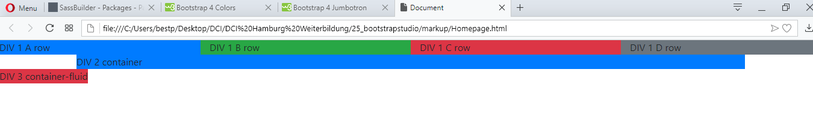

## offline bootstrap

## https://getbootstrap.com

## bootstrap The align-items Property : *stretch vs Flex-start*

Css Example

## -------------------------------------------------------------finish bootstrap…………………………………….

## emmet html5 shortcut

## <https://docs.emmet.io/cheat-sheet/>

note: make sure where is your mouse courser, it muss to be in the end

**css Example**

Css Example

**css Example**

Css Example

**css Example**

Css Example

**css Example**

Css Example

**css Example**

Css Example

**CSS LINK**

<link rel="stylesheet" type="text/css" href="style.css">